BSAN 450 Assignment 9

1) This problem concerns the time series of annual changes in global temperature, 1880-1985. The data is in a file named TemperatureChange.csv and the variable is named Change.

a) Read the data into R Studio. Plot the time series and the difference of the time series. Based on these plots is the original time series stationary? Why or why not? Is the differenced time series stationary? Why or why not? The R commands to produce the plots is below.

library(TSA)

Temperature=read.csv("TemperatureChange.csv")

plot(Temperature$Change,ylab='Temperature Change',xlab='Time',type='o')

plot(diff(Temperature$Change),ylab='Differences in Temperature Change',xlab='Time',type='o')

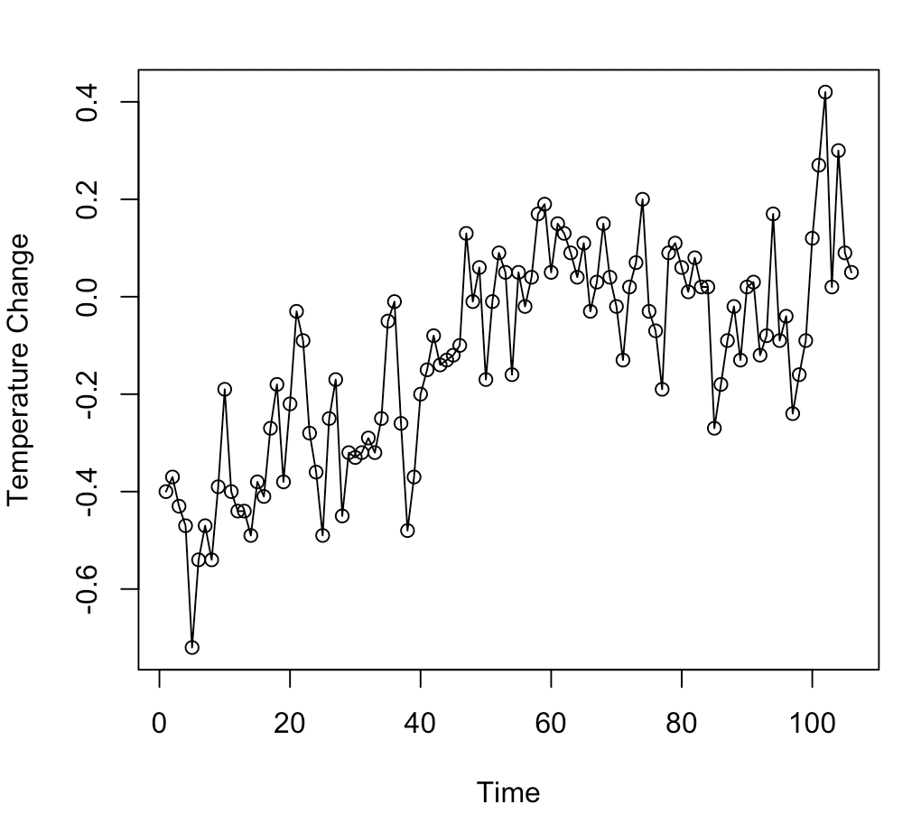 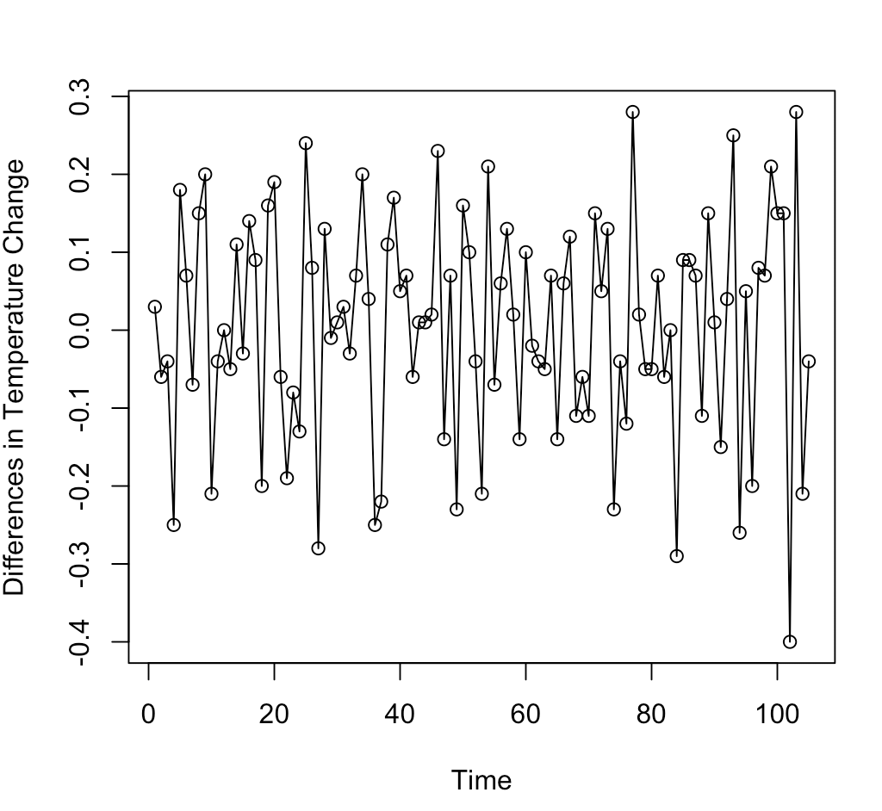

**The original is not a stationary time series because the mean changes as time goes by. The difference in the temperature is a stationary time series because the mean stays about the same and the variance is also about the same.**

b) Plot the sample ACF of the original time series. Based on the sample ACF and the time series plot of the original time series is the original time series stationary? Why or why not?

acf(Temperature$Change,ci.type='ma')

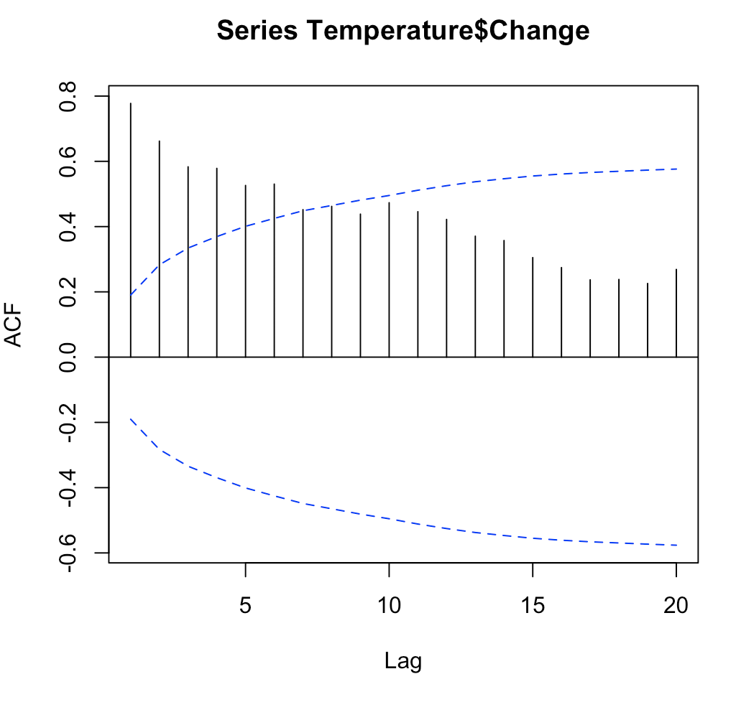

**No the mean does not stay consistent, and the ACF dampers off after 6 lags but appears that it might be increasing again at the end and not continuing to damper off.**

c) Plot the sample ACF and the sample PACF of the difference of the time series. Based on these plots determine a model that is appropriate for this data.

acf(diff(Temperature$Change),ci.type='ma')

pacf(diff(Temperature$Change))

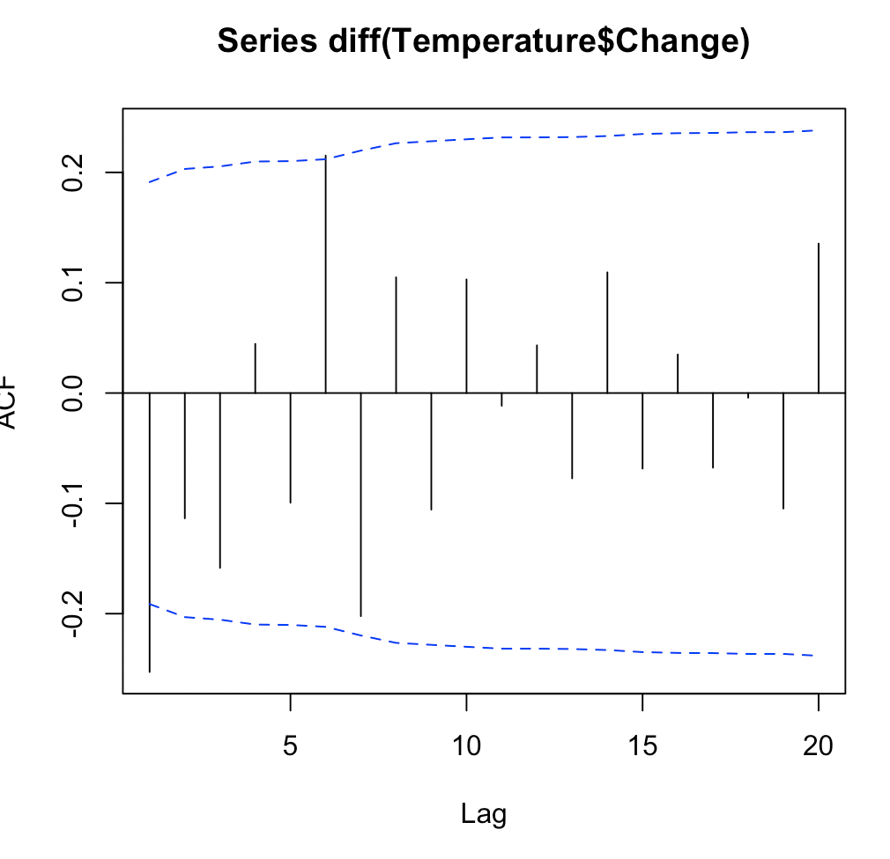 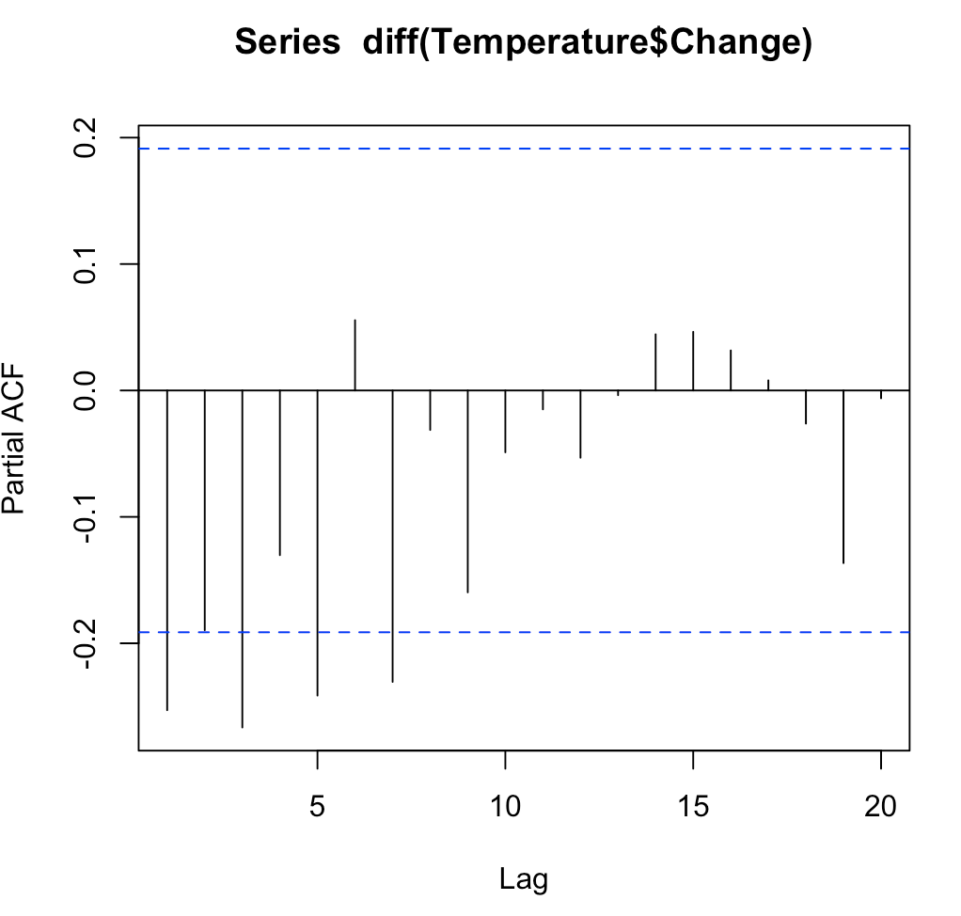

**MA(1) appears to work for this time series based on the plots, because it tampers off after 1 lag.**

d) Fit the model that you identified for this time series. Perform the diagnostic checks for this model. As part of the diagnostic checks fit a more complex model(s).

The R command to fit a model are given below. You will need to change the expression order=c(0,1,1) depending upon what model you wish to fit. In this expression the first number is the AR order, the second number is the number of differences, and the third expression is the MA order. Thus the command as written an ARIMA(0, 1, 1) model will be fit.

fit=arima(Temperature$Change,order =c(0,1,1))

fit

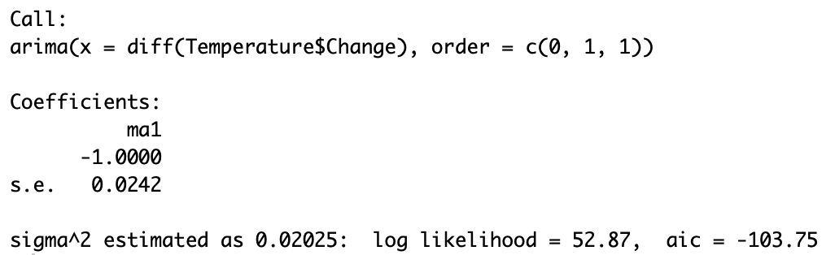

The R commands to do the diagnostic checks are given below. In the last command, the expression fitdf = 1 may need to be changed depending on the model you fit. The number should be the total number of AR plus MA parameters in the model.

plot(rstandard(fit),ylab='Standardized Residuals',type='o')

hist(rstandard(fit))

qqnorm(residuals(fit))

qqline(residuals(fit))

acf(rstandard(fit))

Box.test(residuals(fit),lag=10,type="Ljung",fitdf=1)

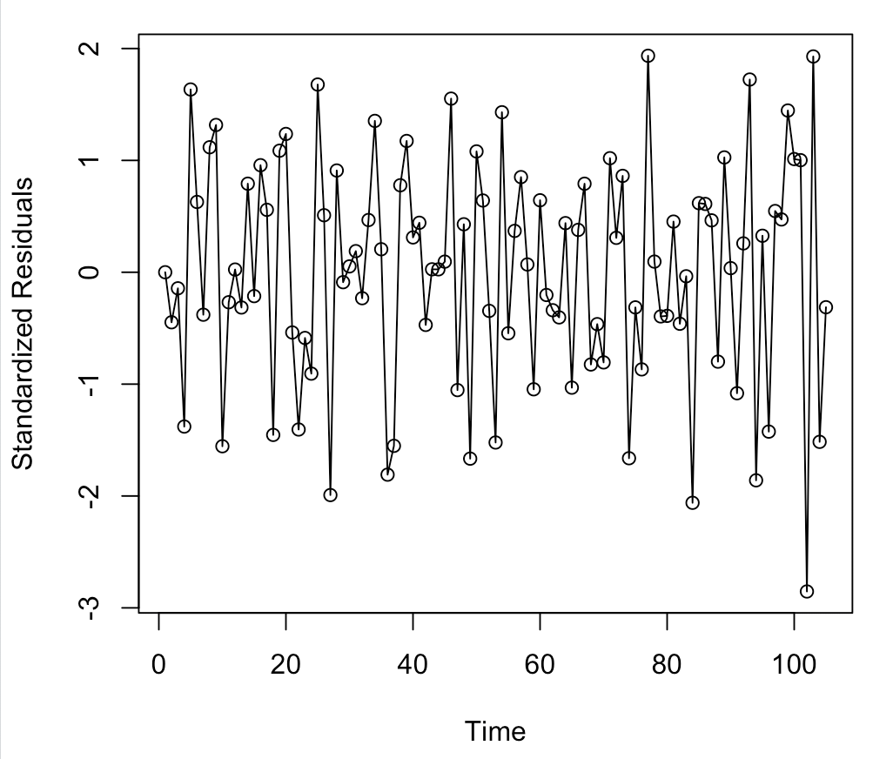 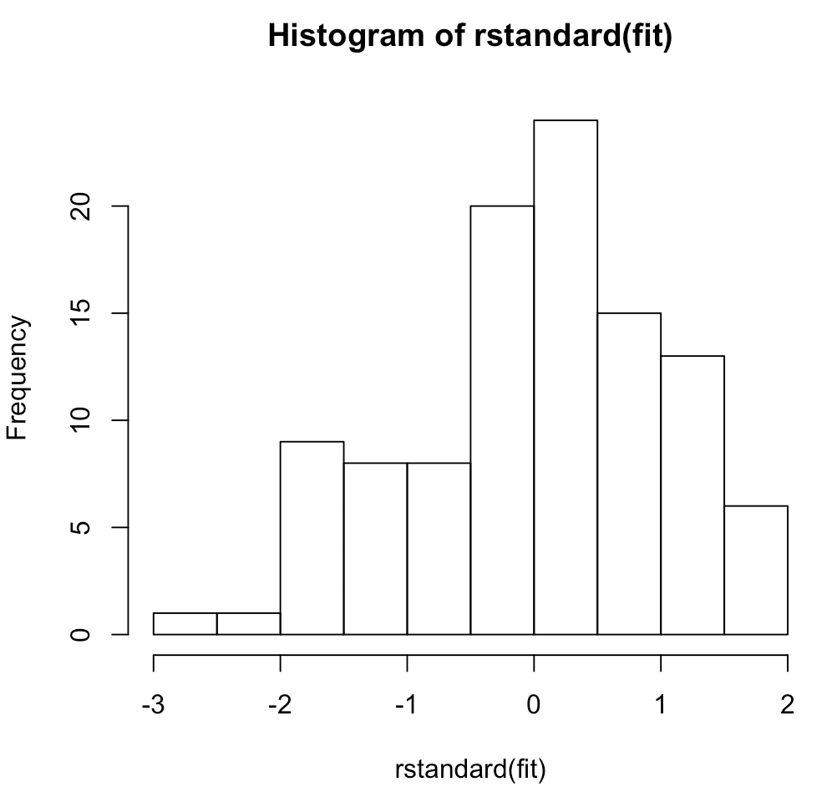

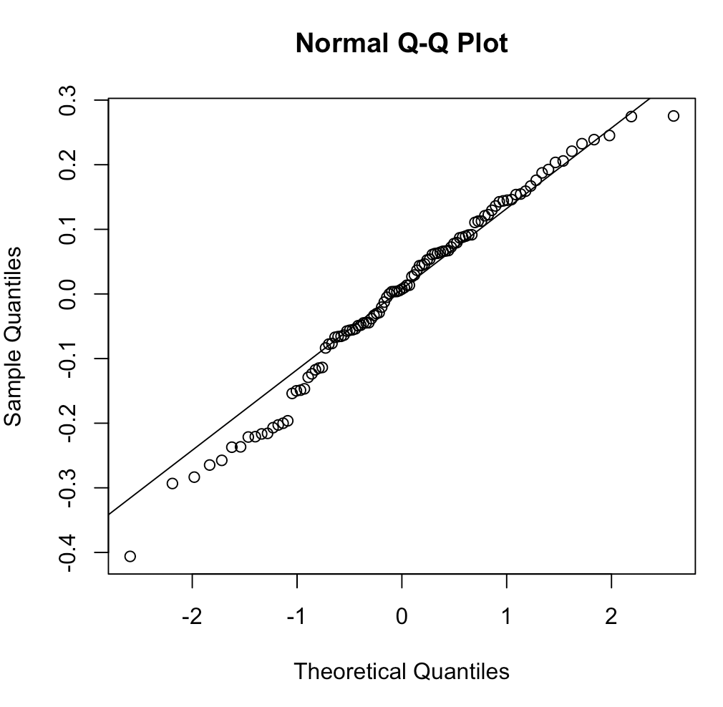 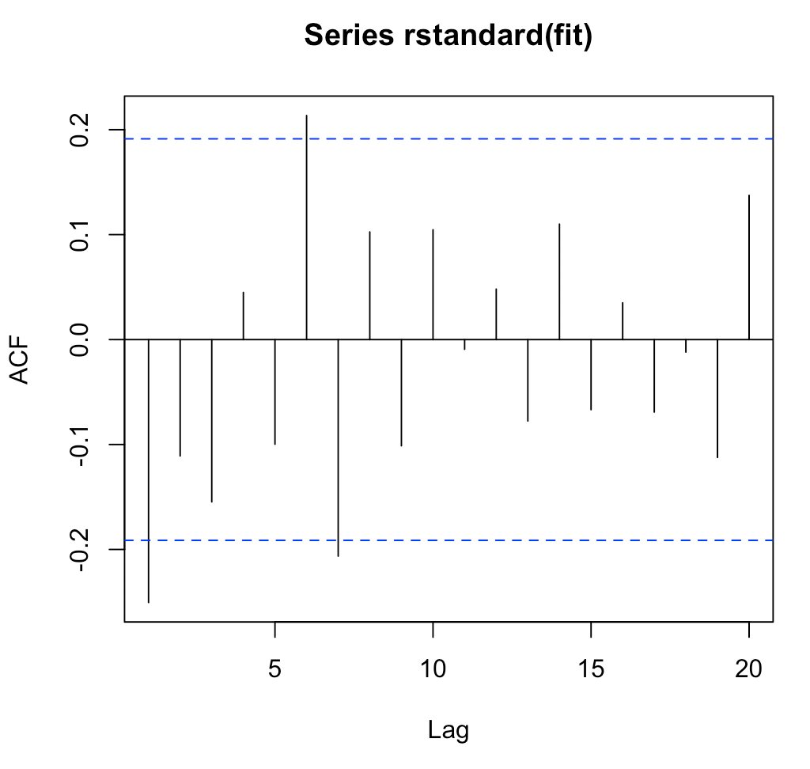

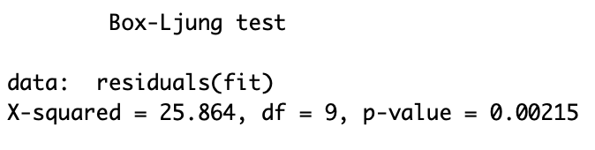

**The diagnostics look ok. The histogram is slightly top heavy. And the box-ljung test indicates that this might not be the best fit as the p-value is < .05**

e) For the model you believe best fits this data, forecast the next 10 years of data. The R commands to do this follow.

plot(fit,n.ahead=10,type='b')

predict(fit,n.ahead=10)

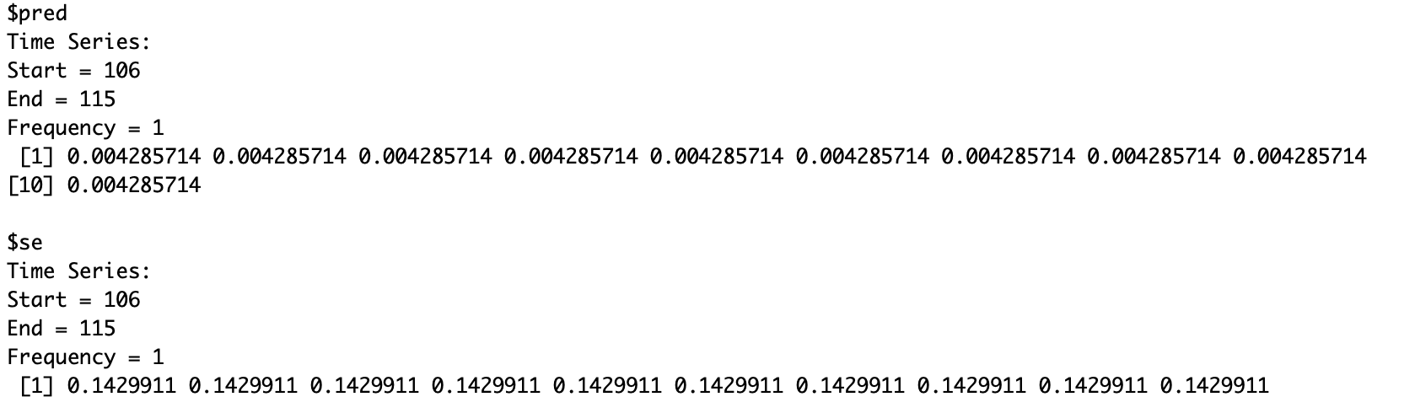

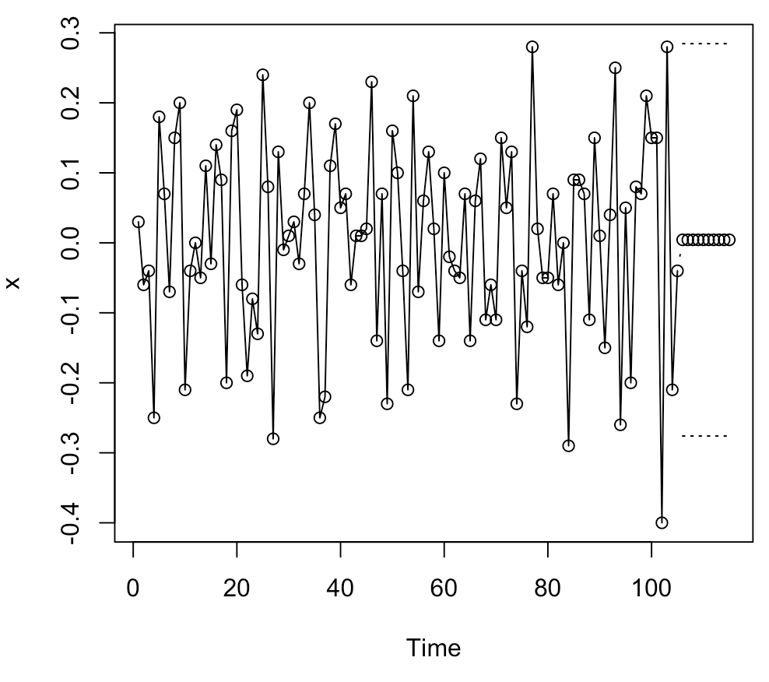

2) The data for this example is the weekly sales of a cutting tool. The data is in a file named CuttingTool.csv and the name of the data is Sales.

a) Read the data into R Studio and plot the sales data. Based on this plot is the time series stationary? Justify your anwer.

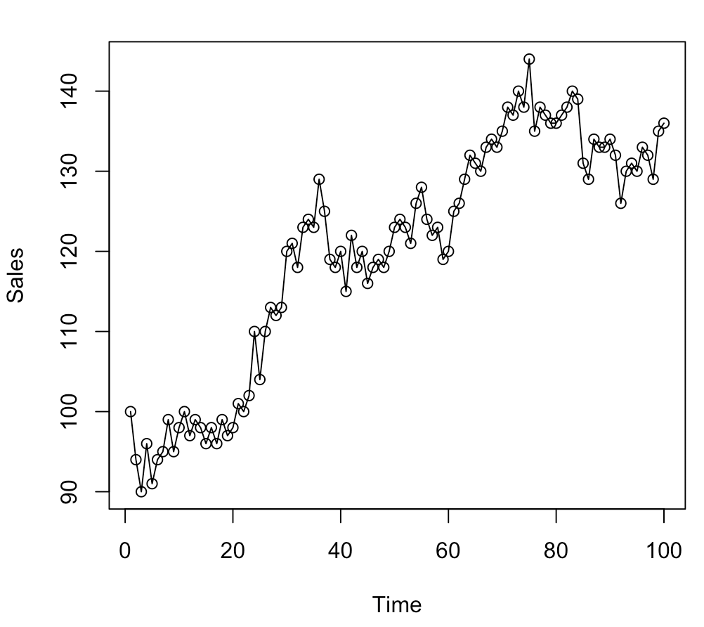

**The plot indicates that this is not a stationary time series because the mean of the values changes as time goes by. Also, the variance is not constant.**

b) Plot the difference of the sales data. Is the differenced data stationary? Justify your answer.

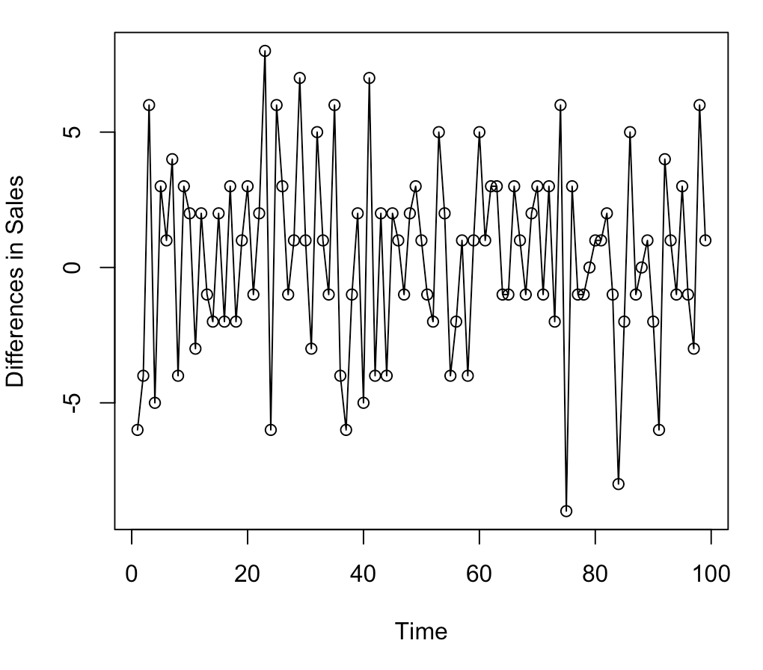

**The plot indicates that this is a stationary time series because the mean of the values stays about the same as time goes by. Also, the variance is relatively constant.**

c) Plot the sample ACF of the differenced data. Does this plot suggest that the sales data is stationary? Does this conclusion agree with the information in the time series plot?

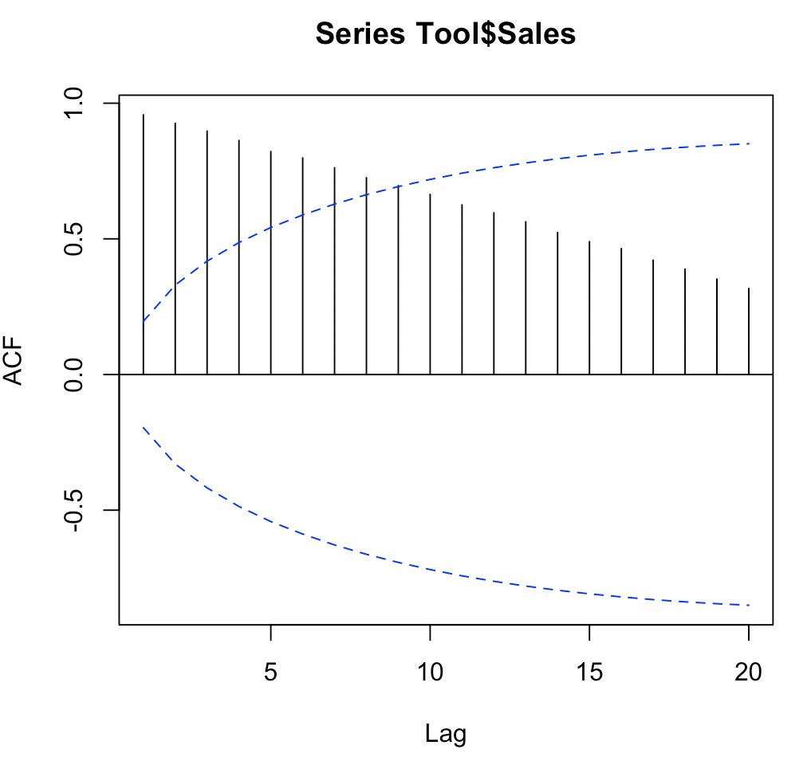

**This plot suggests that potentially an ARMA fit would work as it looks like the lags are decreasing over time.**

d) Plot the sample ACF and the sample PACF of the differences in sales. Based on these plots identify a model that you think is appropriate for this data.

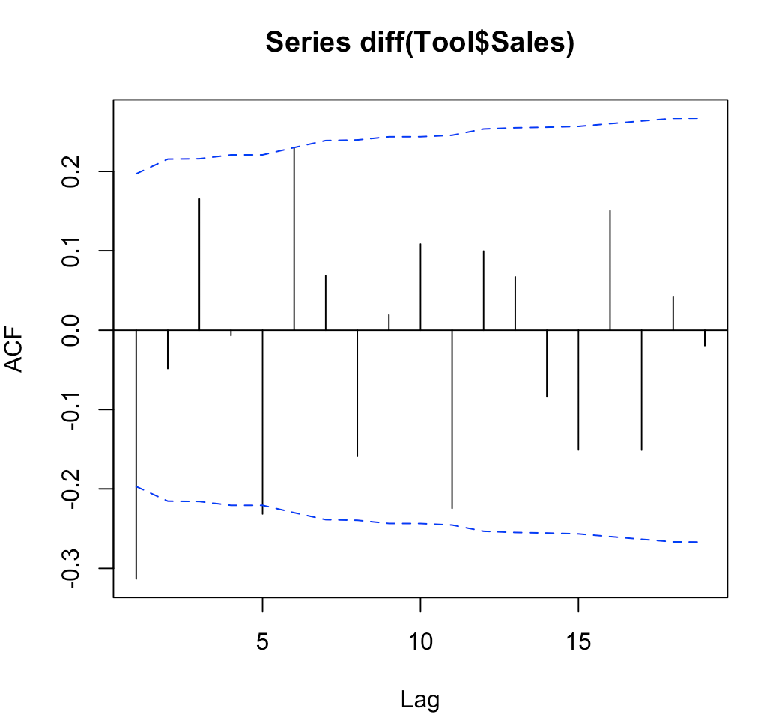 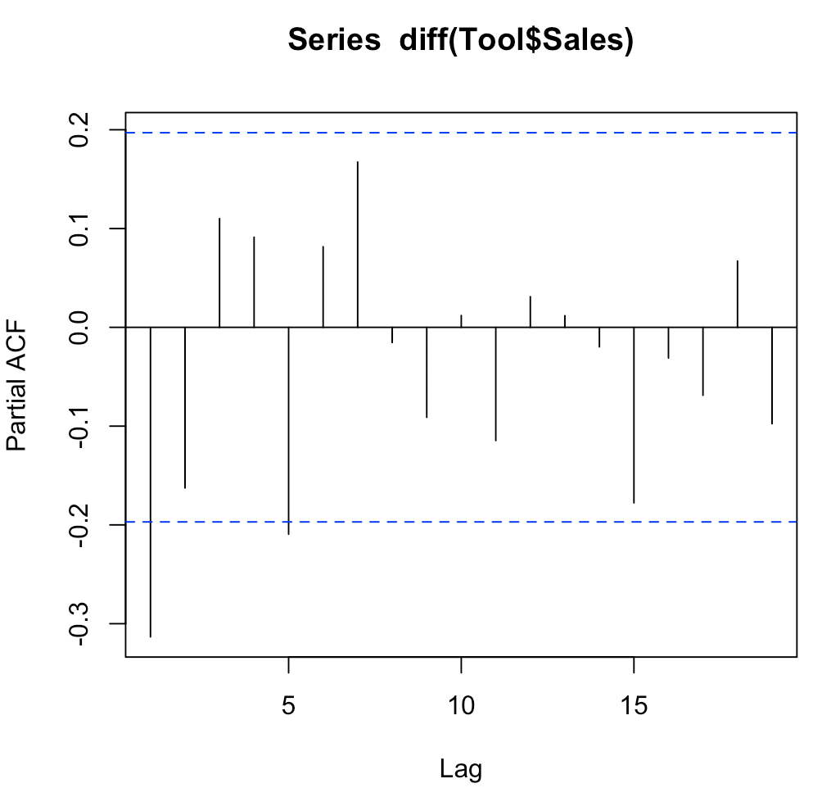

**Based on the plots either AR(1) or MA(1) would work.**

e) Fit the model you identified. Perform the diagnostic checks for this model. Note that you need to fill in the appropriate values in the expression order=c( , , ,) in the first listed command. You may also have to modify the expression fitdf=1 in the last command – the number should be the number if AR parameters plus the number of MA parameters in your model.

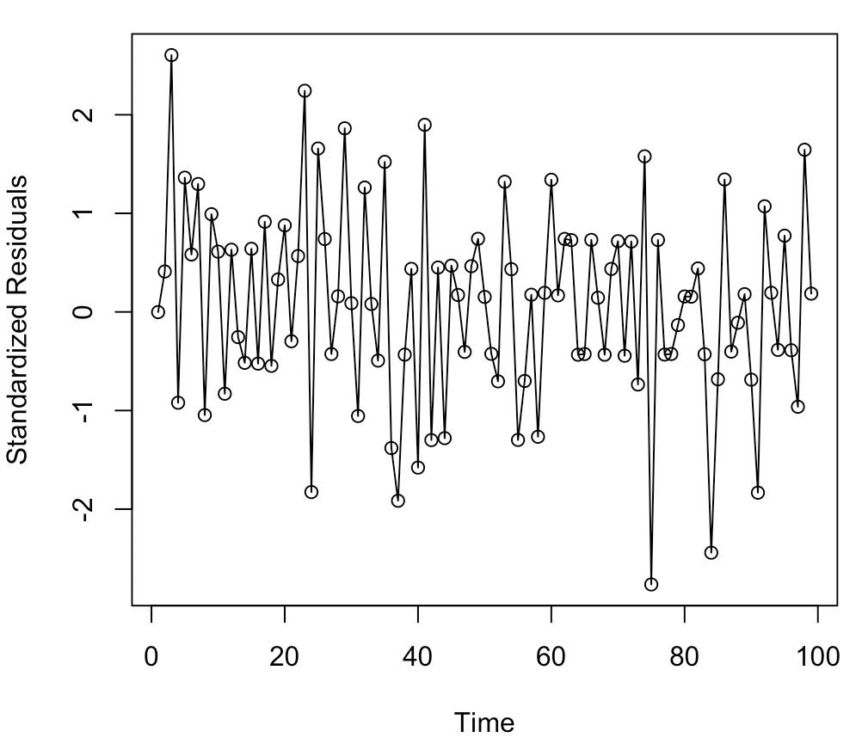 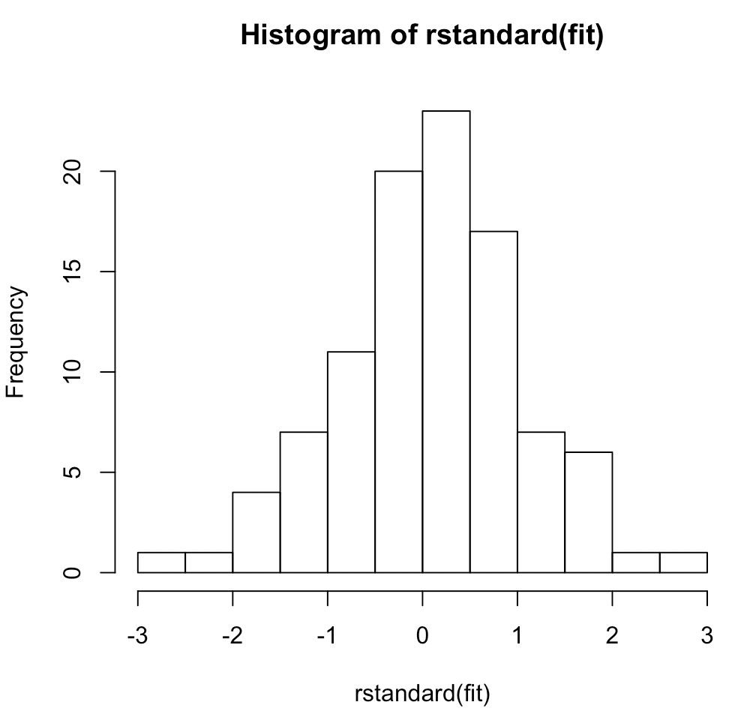 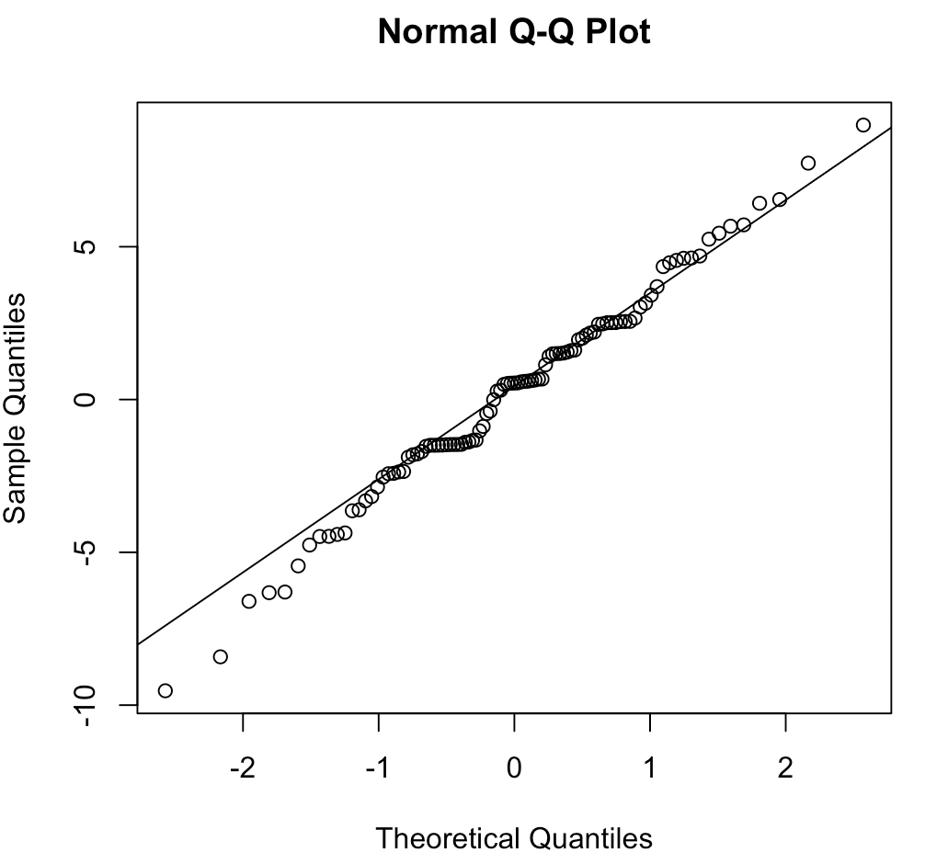 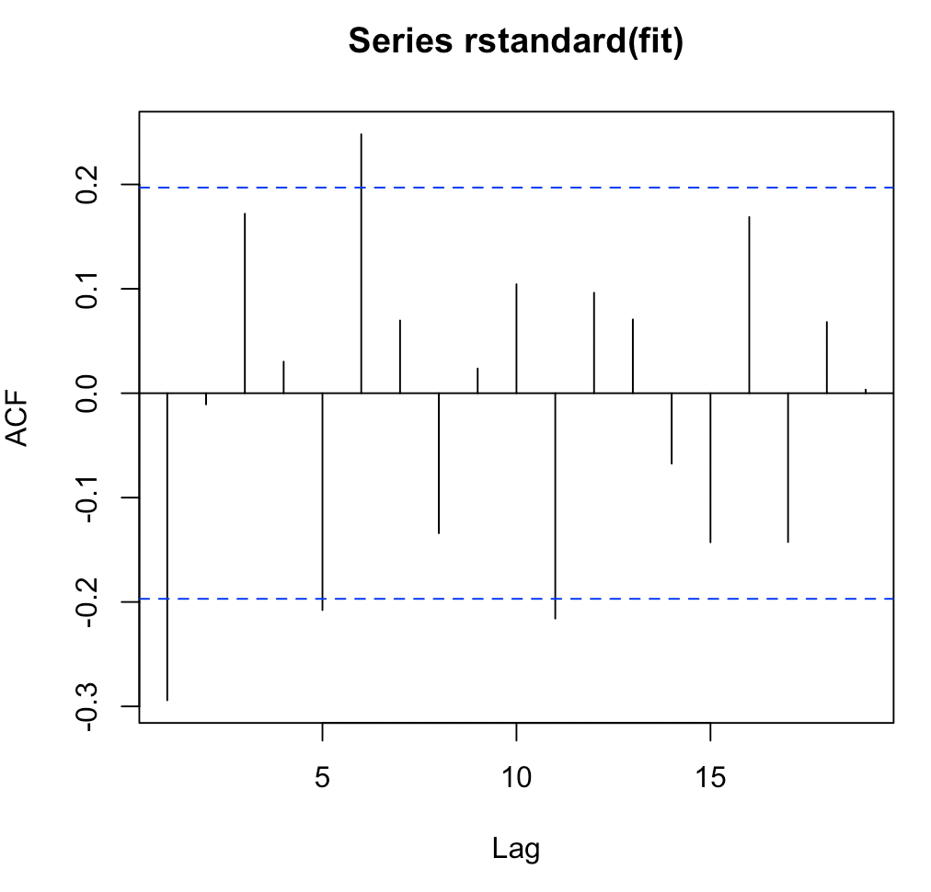

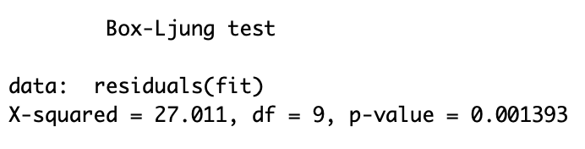

**The diagnostics look ok. And the box-ljung test indicates that this might not be the best fit as the p-value is < .05. The QQ plot also is a little wavy.**